What is Human Intelligence

Ability to perform complex tasks

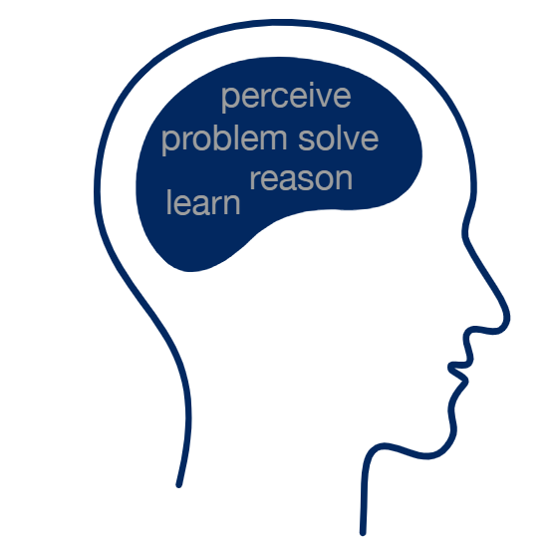

What is AI

AI is typically defined as the ability of a machine to perform cognitive function like human minds, such as perceiving, reasoning, learning, interacting with the environment, problem solving, creativity

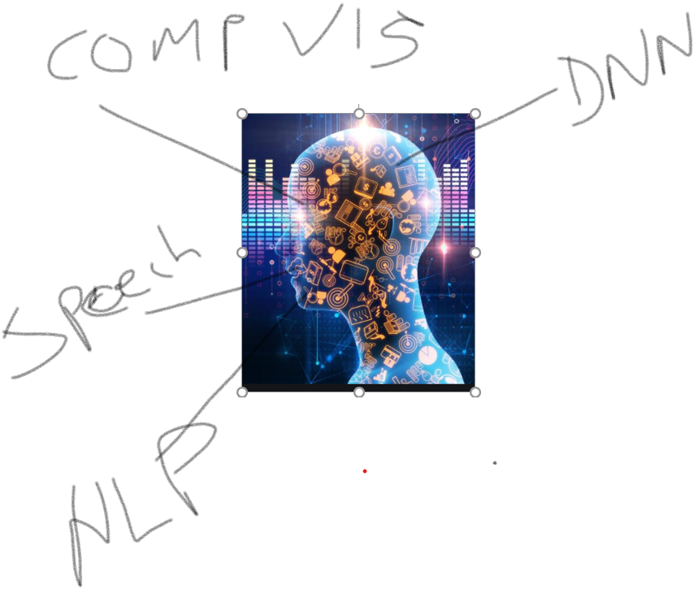

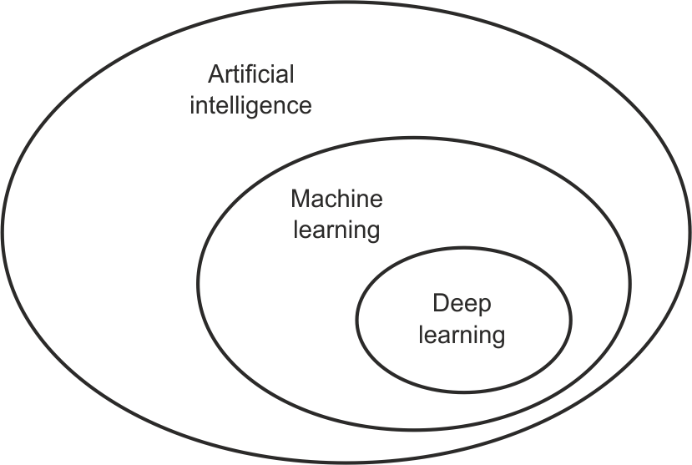

Machinelearning algorithms detect patterns and learn how to make predictions and recommendations by processing data and experiences, rather than by receiving explicit programming instruction

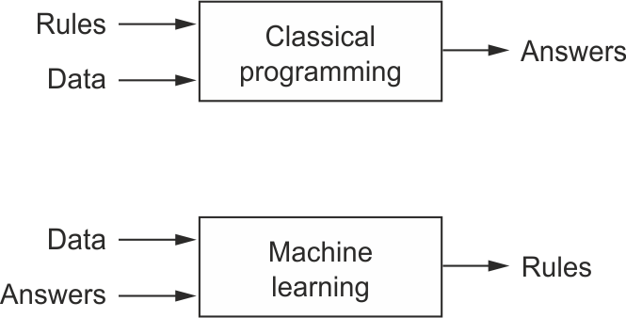

Deep learning-Deep learning is a type of machine learning that can process a wider range of data resources, requires less data preprocessing by humans, and can often produce more accurate results than traditional machine-learning approaches

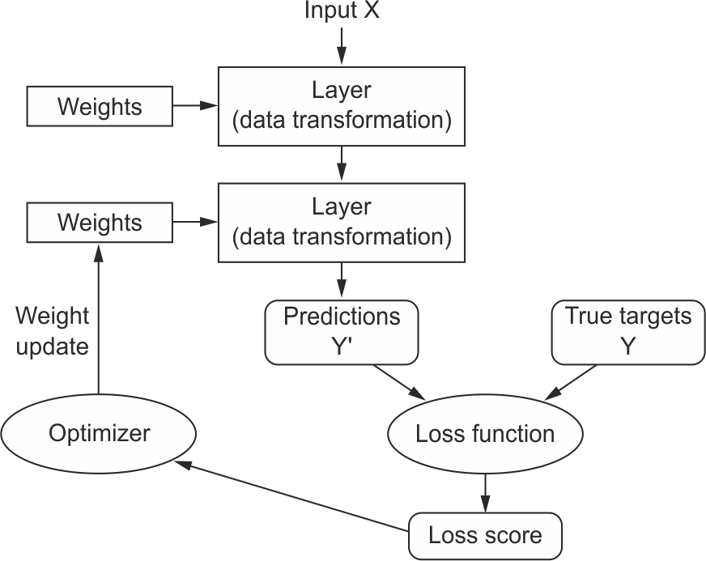

Open Browser- Step 1

Click on google- Step 1

Enter text Simplilearn

Clck

Click on Search

Open Excel

Paste the text

Sending Email